HEALTHCARE DATASET KENYA

This dataset, which contains information on health facilities in Kenya, was obtained from Open Africa (http://www.ehealth.or.ke/facilities/downloads.aspx) and last updated on November 30, 2023. I aim to uncover insights into the healthcare sector in Kenya and provide recommendations for improvements as well as conclusions. I analyzed this dataset using SPSS, Python and Microsoft Excel.

**EXPLORATORY DATA ANALYSIS**

1. Data cleaning and preparation

* The dataset contains 10,505 values and is distributed into 49 different columns. Some columns however, had no information and I dropped them.
* I filled blank values that weren’t very essential with “N/A” or 0 values depending on the context
* I added various columns to easily categorize the data into sub-groups, for instance the “Category” column which contains counties subdivided into either Rural, Urban or Urban-Rural.

1. Descriptive statistics

|  |  |  |  |  |  |
| --- | --- | --- | --- | --- | --- |
| **Descriptive Statistics** | | | | | |
|  | N | Minimum | Maximum | Mean | Std. Deviation |
| Beds | 10505 | 0 | 1455 | 5.39 | 29.743 |
| Cots | 10505 | 0 | 1000 | .74 | 11.291 |
| Valid N (listwise) | 10505 |  |  |  |  |

Beds and Cots are the only continous variables and these are their descriptive statistics. The minimum value for beds is 0 and the maximum 1455, while the minimum of cots is zero and the maximum is 1000.

**VISUALIZATION AND ANALYSIS**

1. **Facilities distribution across various counties**

* There are a total of 47 counties in Kenya. The average number of facilities is 223.

**Counties with the largest number of facilities**

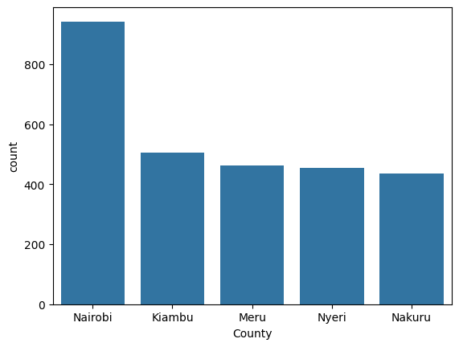

*Barplot showing counties with the largest number of facilities*

* Nairobi county has the highest number of facilities with over 900 facilities, it is followed by Kiambu though the gap is large, and Meru, Nyeri, and Kiambu. All these counties apart from Meru are Urban centers.

**Counties with the lowest number of facilities**

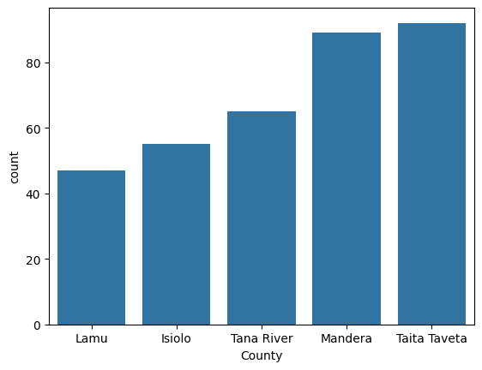

*Barplot showing the counties with the least number of facilities*

* The county with the least number of facilities is Lamu with less than 50 facilities. This is about 18 times less than the number of facilities in Nairobi.
* This calls for action in Lamu. Lamu is closely followed by Isiolo, Tana River, Mandera and Taita Taveta.

1. **Types of facilities**

|  |  |
| --- | --- |
| *Cluster plot showing top 5 facility category* |  |
|  |  |

* There is a grand total of 10,505 facilities and the type of facility that is most common is Dispensary with close to half of the total facilities(4820). A dispensary is a facility provided by public or charity funds. Dispensaries, Medical clinics and Health centers are the most popular types of facilities.
* Facilities like Blood Bank , Funeral Home (Stand-alone), and Rural Health Training Centre have only one facility.

**Distribution of ownership of Healthcare facilities**

|  |
| --- |
| Ministry of Health 4687 |
| Private Enterprise (Institution) 1366 |
| Private Practice - Nurse / Midwife 1026 |
| Private Practice - Clinical Officer 615 |
| Private Practice - General Practitioner 434 |
| Kenya Episcopal Conference-Catholic Secretariat 412 |
| Christian Health Association of Kenya 390 |
| Non-Governmental Organizations 350 |
| Other Faith Based 283 |
| Private Practice - Unspecified 242 |
| Private Practice - Medical Specialist 169 |
| Community 109 |
| Local Authority 106 |
| Company Medical Service 86 |
| Other Public Institution 81 |
| Community Development Fund 39 |
| Academic (if registered) 37 |
| Armed Forces 24 |
| Parastatal 20 |
| Supreme Council for Kenya Muslims 13 |
| Humanitarian Agencies 6 |
| Local Authority T Fund 5 |
| State Coorporation 5 |
|  |

*Table showing the distribution of ownership of different health facilities*

The top owner of the institution is the Ministry of Health with over 4500 owned facilities. Out of these,

*Cluster plot showing the largest number of facilities owned by the Ministry of Health*

Dispensaries are the most common, which means that a large number of dispensaries are owned by the Ministry of Health.

**Geographical analysis**

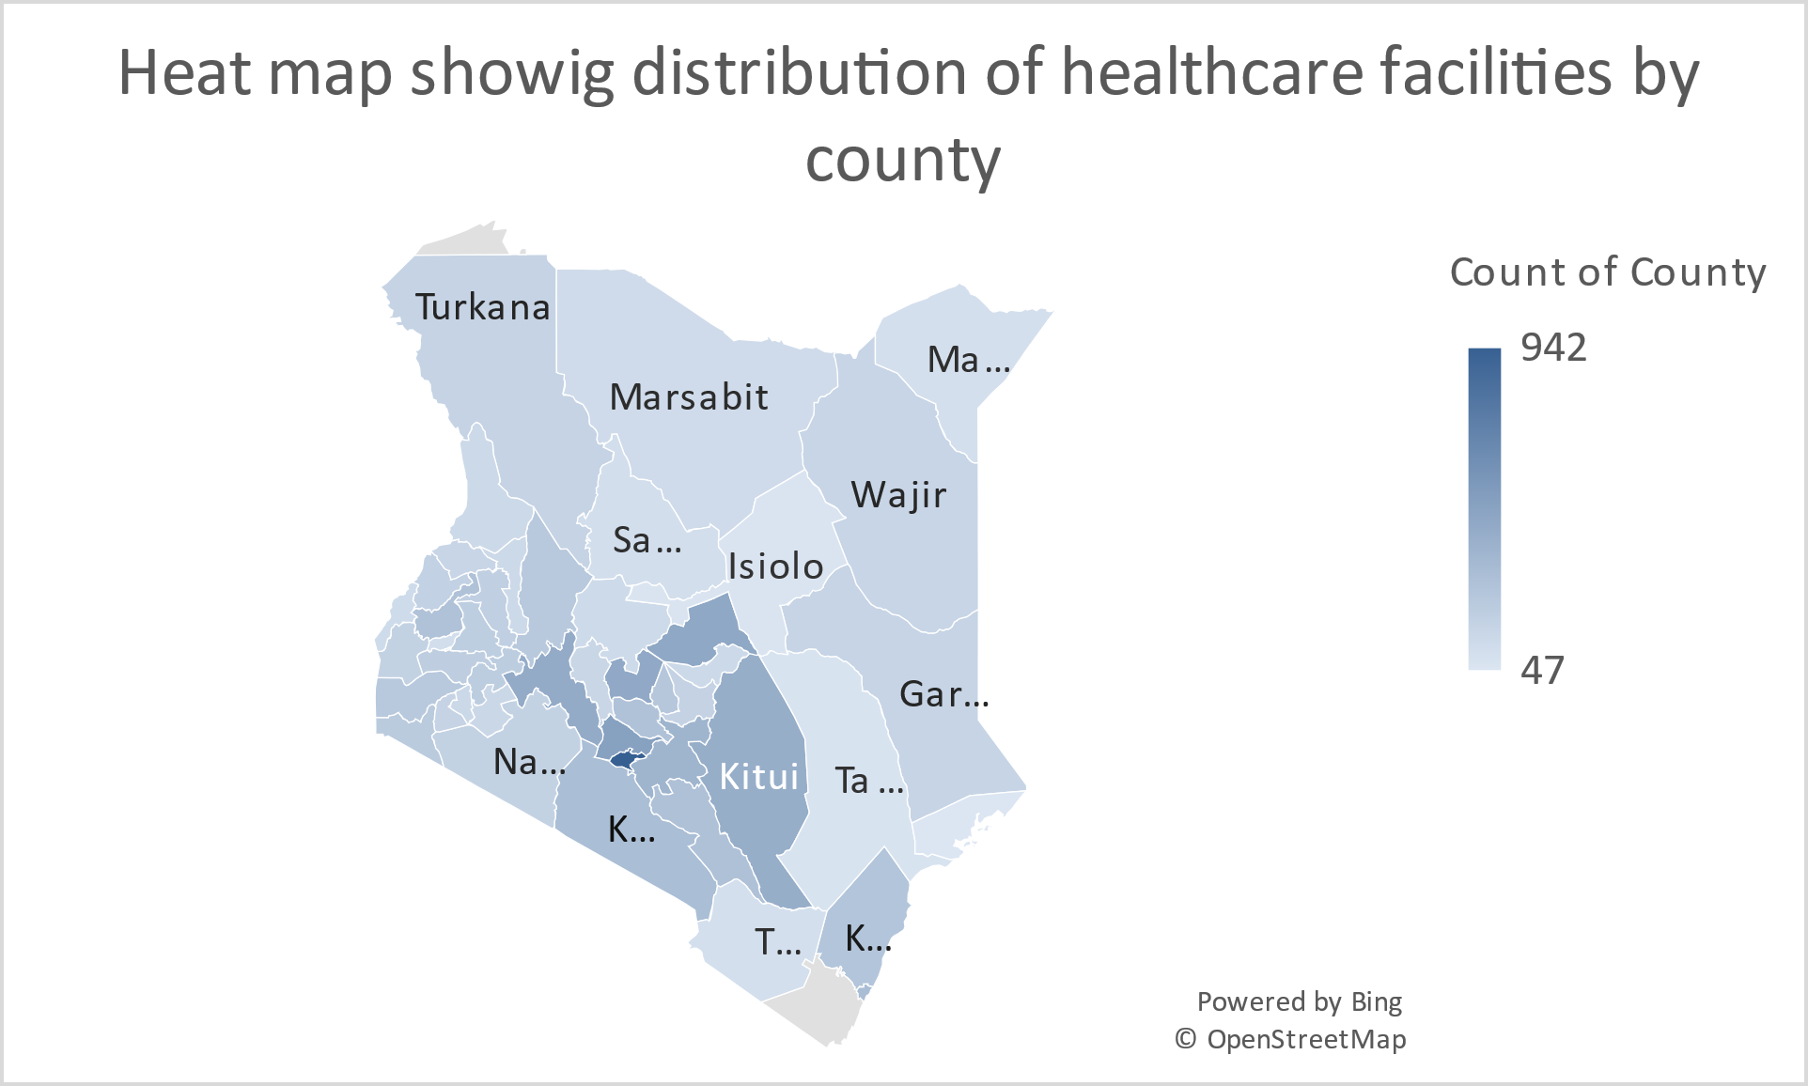

*Heat map showing distribution of facilities by county.*

*More color shows a higher amount of facilities in the county.*

**Distribution of Health Facilities by Category**

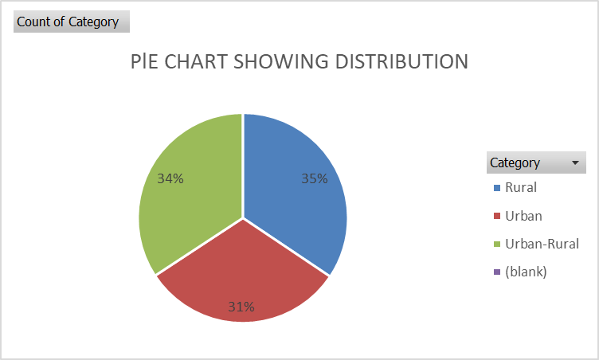

*Distribution of healthcare facilities according to categories*

Rural areas have the largest number of facilities at 35%. Urban areas have the least amount of facilities despite Nairobi, an urban center having the largest amount of facilities.

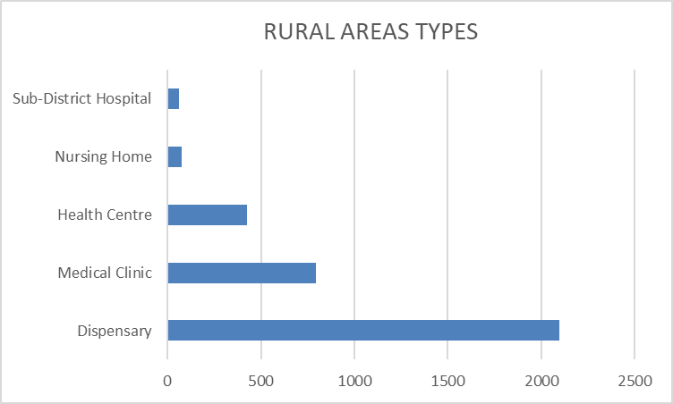

*Barplot showing the top 5 common facility type in Rural areas*

The top 5 types of clinics in Rural areas are shown in the cluster plot above.

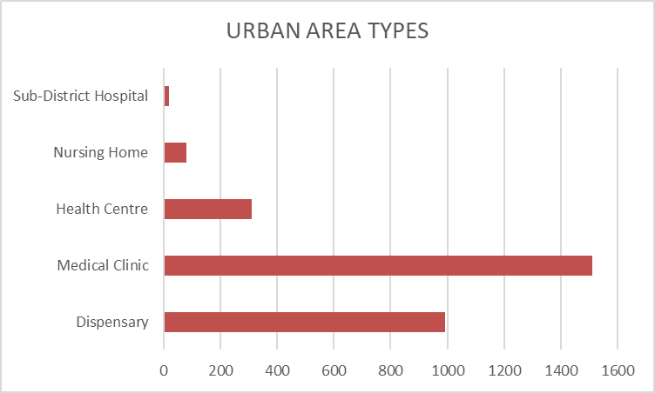

*Barplot showing the top 5 common facility type in Urban areas*

Dispensaries are the most common healthcare facilities in Rural areas, while in Urban centers, the most common facilities are medical clinics.

Service availability analysis

**Availability of beds**

*This graph contains the top 5 counties with the highest number of beds*

Nairobi county has the highest number of beds per county, and is followed by Kiambu, Nakuru, Kisii and Kisumu. It is interesting to note that Kisii, despite not being an urban center appears in this list.

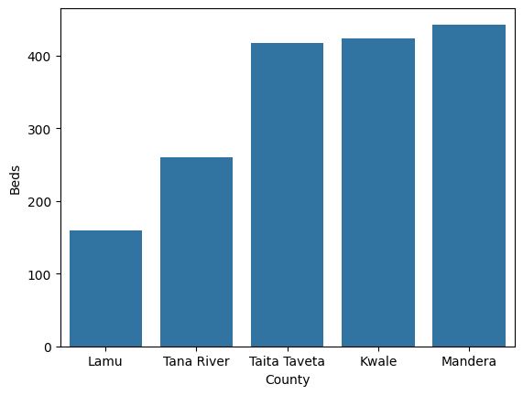

*Barplot shows counties with the least amount of beds.*

Lamu county has the lowest amount of beds. Lamu appears once again as one of the poorly performing counties in terms of facilities and now beds. It is followed by Tana River, Taita Taveta, Kwale and Mandera.

Cots Available

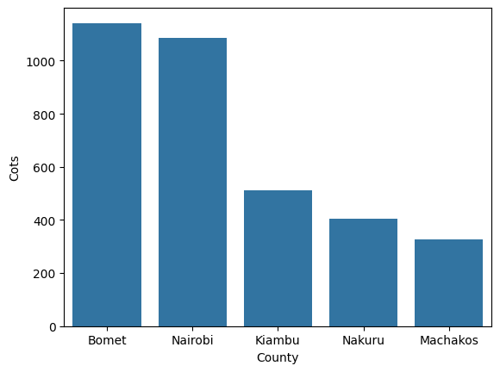

*Barplot shows counties with the largest number of baby cots*

* Bomet county has the largest number of baby cots and this is commendable. It is followed by Nairobi, Kiambu, Nakuru and Machakos.

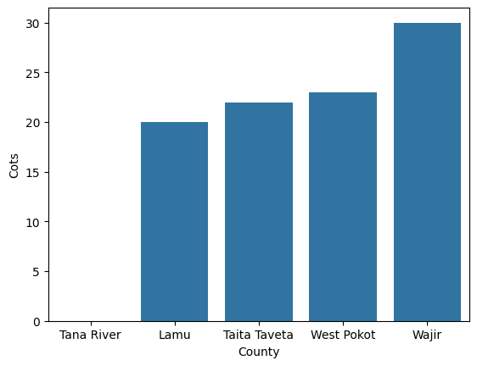

*The barplot below shows counties with the least number of cots available*

* It is very alarming to note that Tana River county does not have any cots. Other counties with low numbers are Lamu, Taita Taveta, West Pokot and Wajir.

**Service quality analysis**

**Availability of specialized services** (e.g., ANC, ART, BEOC, CEOC, TB treatment, PMTCT).

1. ART SERVICES

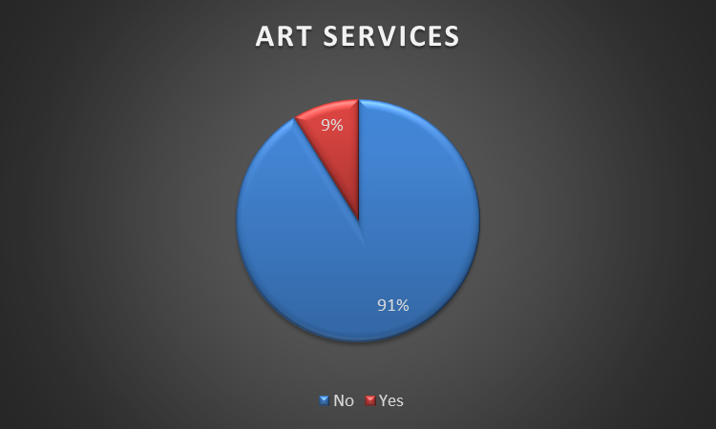

* ART services are Antiretroviral treatment which basically are healthcare facilities that offer HIV/AIDS treatment.
* A very small percentage (9%) of healthcare facilities offer these services, Over 15 counties have less than ten facilities.

*Clusterplot showing counties with less than 10 ART centers*

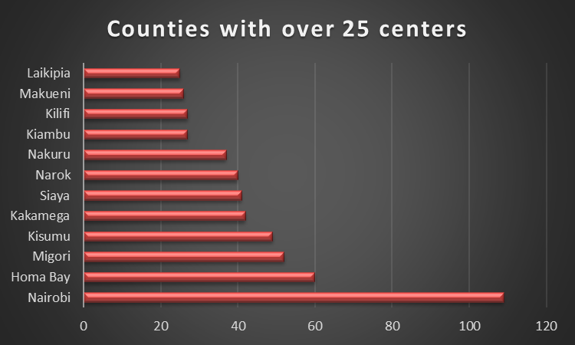

* These are the counties with the largest number of A.R.T. services. It is interesting to note that other than the Nairobi, the other 5 counties are located in the western region of the country where the prevalence of HIV/AIDS is very high.

*Counties with over 25 ART facilities*

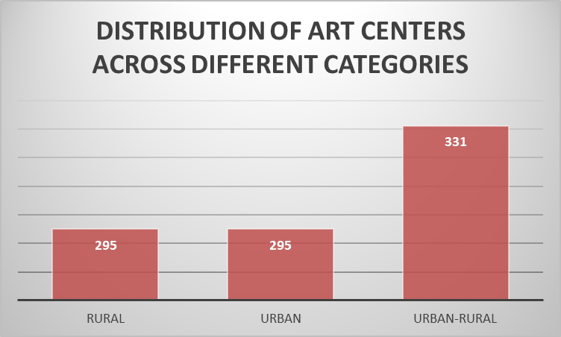

*Clusterplot showing distribution of A.R.T. centers across different categories*

* Urban-Rural areas have the highest number of A.R.T. centers, and rural and urban centers have the same amount of centers.

1. C-IMCI Facilities

CMCI’s short for Community Integrated Management of Childhood Illnesses are programs focused on preventing and treating common childhood diseases like pneumonia, diarrhea, and malaria at the community level.

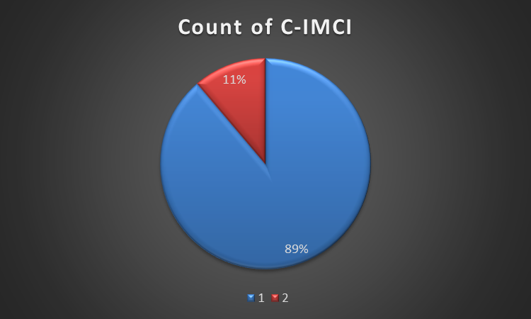

11% of Healthcare facilities in Kenya offer these services while 89% of the facilities do not have these facilities.

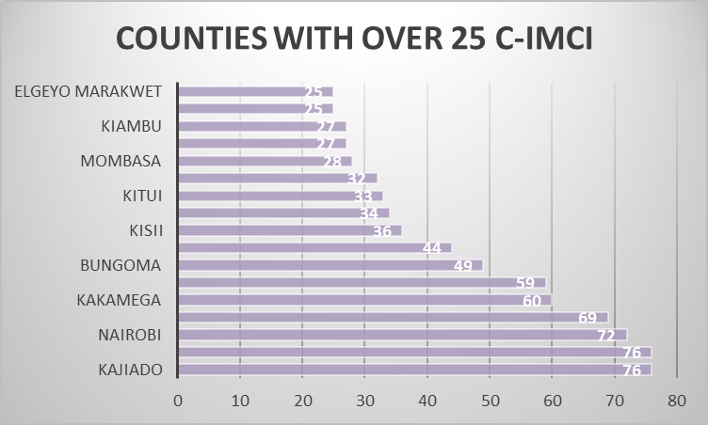  
*Barplot showing counties with over 25 C-IMCI health facilities*

* It is commendable to see that Kajiado has the highest number of C- IMCI health facilities. Nairobi and a number of western counties follow it. Western counties are also remarkable in service provision.

*Clusterplot showing counties with less than 10 C-IMCI health facilities*

* These counties have less than 10 C-IMCI health facilities and some action needs to be taken.

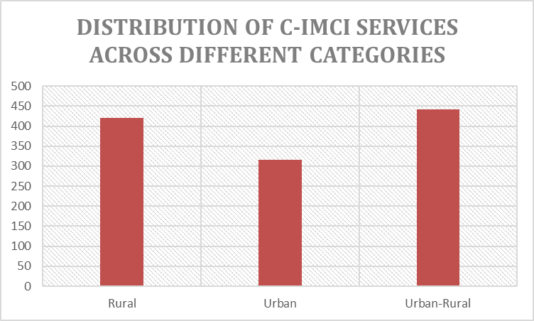

*Clusterplot showing the distribution of C-IMCI Services across different categories*

1. Family planning services (FP)

Indicates whether the facility offers contraceptive and reproductive health services to help people plan pregnancies.

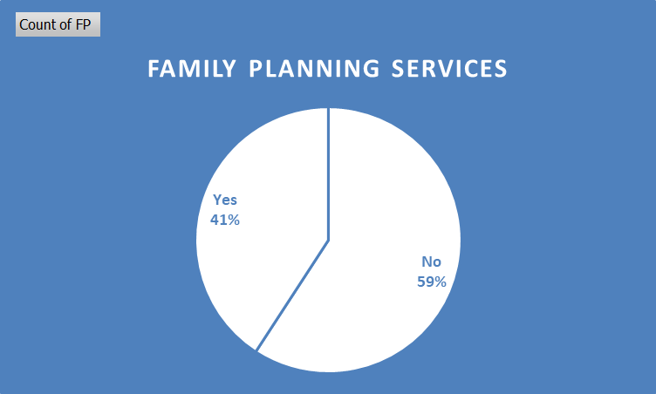

*Pie chart showing distribution of family planning services offered in healthcare facilities.*

* 41% of the healthcare facilities offer family planning services while 59% do not offer these services. This is by far the most common service offered in facilities.

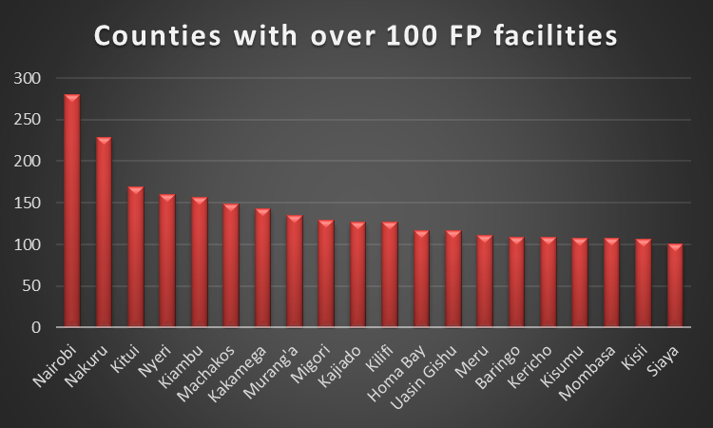

*Clusterplot showing counties with over 100 family planning facilities*

* Nairobi, Nakuru, Kitui, Nyeri and Kiambu are the top 5 counties with family planning facilities.

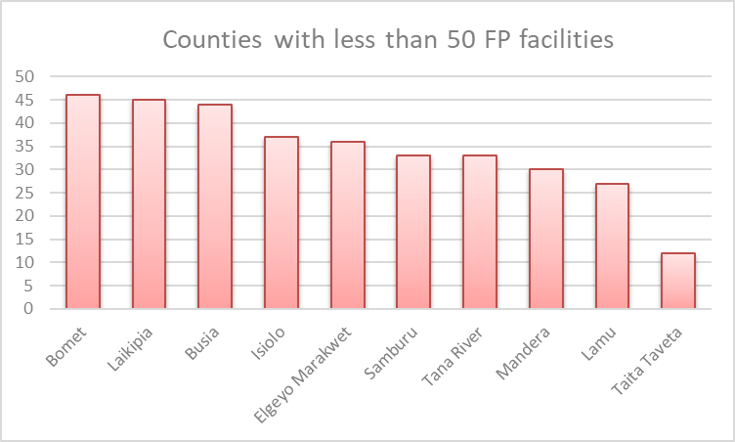

*Clusterplot showing counties with less than 50 Family Planning Facilities*

* These counties do not have a large number of Family Planning facilities and Taita Taveta county has the least amount of facilities.

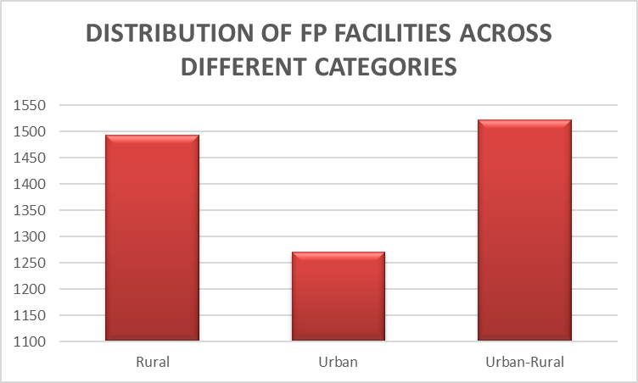

*Clusterplot showing distribution of FP Facilities across different categories*

* The Urban-Rural category also has the highest number of Family planning facilities.

**HBC Facilities**

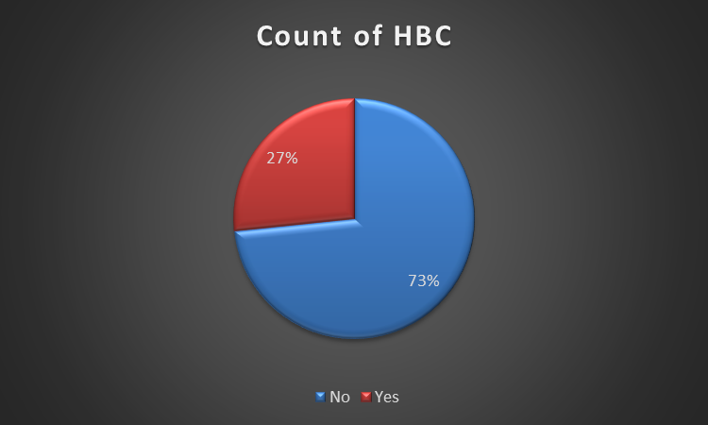

* HBC Services are provided for patients, usually those with chronic illnesses at home instead of in a hospital. 27% of the healthcare facilities provide HBC services while 73% of facilities do not provide these services.

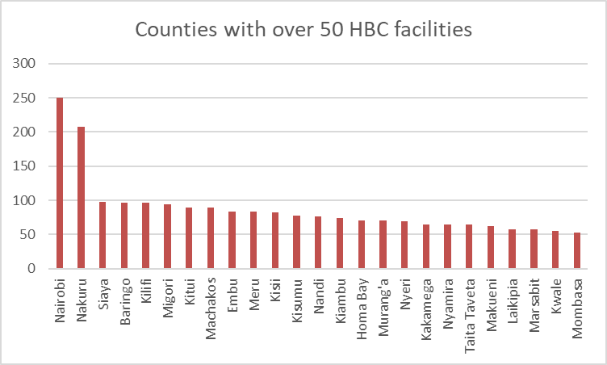

*Barplot showing counties with over 50 HBC facilities*

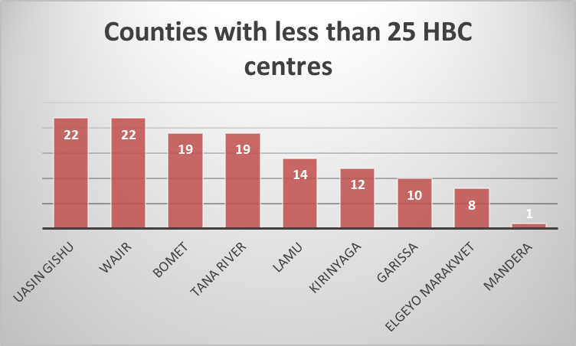

*Cluster plot showing counties with less than 25 HBC facilities*

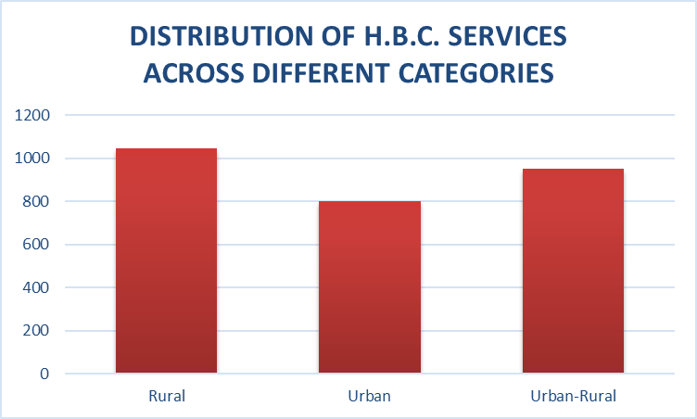

*Clusterplot showing distribution*

1. IPD Facilities

This shows if the facility has beds for admitting and treating patients overnight.

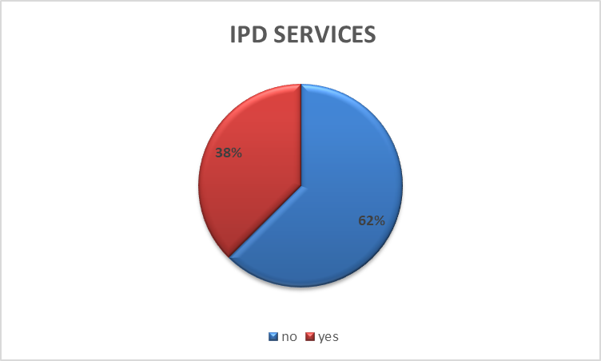

*Pie chart showing facilities that offer IPD services*

38% of healthcare facilities in Kenya offer IPD services

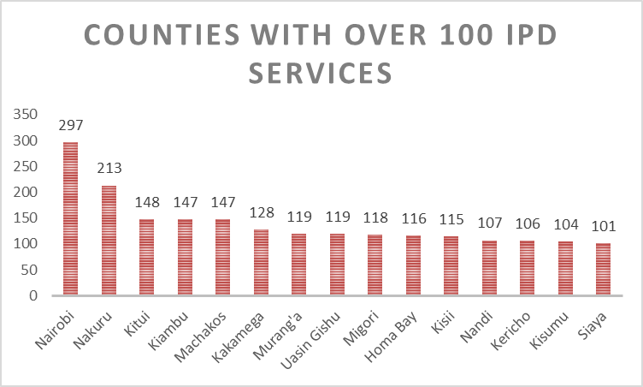

*Cluster plot showing counties with over 100 IPD services*

*Clusterplot showing counties with less than 50 IPD services*

*Clusterplots showing the distribution of H.B.C. services across different categories*

IPD’S distributions in different categories

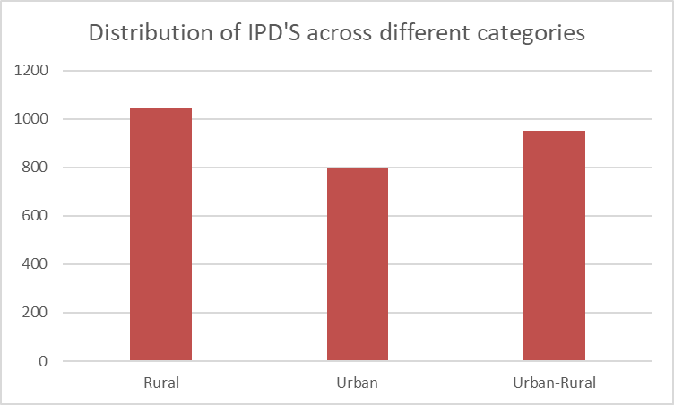

*Barplot showing the distribution of IPD’S across different categories*

Rural areas have the largest number of IPD’S

**Proportion of facilities operating 24 hours or on weekends**.

**Weekends**

* 39% of facilities are operational on weekends while 69% are not on weekends.

**24 hours**

* 15% of facilities are operational 24 hours a day while 85% of facilities are not operational for 24 hours a day.

**Facility quality indicators**

Proportion of operational and non operation

|  |  |
| --- | --- |
| **Row Labels** | **Proportion** |
| Not-Operational | 5.04% |
| Operational | 90.92% |
| Pending Opening | 3.82% |
| Unknown | 0.23% |

Over 90 percent of the healthcare facilities are operational, while 5% are not operational.

3% of the healthcare facilities have not been opened yet and 0.23% of these facilities are unknown if they are operational or not.

**Comparison of government vs. private facilities**

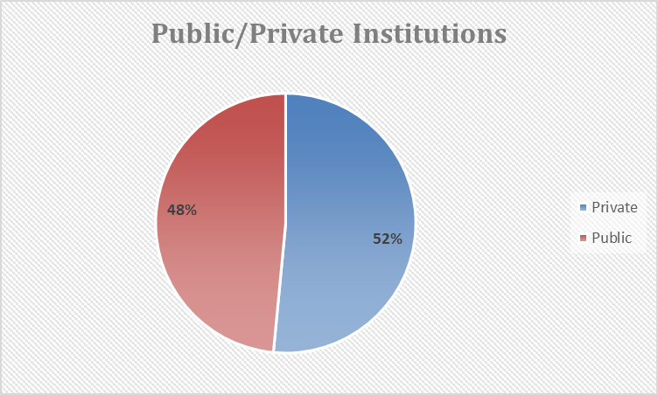

*Pie chart showing public and private owned facilities*

A large number of the facilities in Kenya are privately owned at 52% of the total, while 48% are publicly owned.

Public facilities have a larger number of beds and cots available in comparison to private facilities.

|  |  |  |  |
| --- | --- | --- | --- |
| **Count of ART** |  |  |  |
| **Row Labels** | **No** | **Yes** | **Grand Total** |
| Private | 5113 | 299 | 5412 |
| Public | 4471 | 622 | 5093 |
| Grand Total | 9584 | 921 | 10505 |
| **Count of C-IMCI** | |  |  |
| **Row Labels** | **No** | **Yes** | **Grand Total** |
| Private | 4895 | 517 | 5412 |
| Public | 4433 | 660 | 5093 |
| Grand Total | 9328 | 1177 | 10505 |
| **Count of FP** |  |  |  |
| **Row Labels** | **No** | **Yes** | **Grand Total** |
| Private | 3773 | 1639 | 5412 |
| Public | 2444 | 2649 | 5093 |
|  |  |  |  |
| Grand Total | 6217 | 4288 | 10505 |
| **Count of HBC** |  |  |  |
| **Row Labels** | **No** | **Yes** | **Grand Total** |
| Private | 4395 | 1017 | 5412 |
| Public | 3312 | 1781 | 5093 |
| Grand Total | 7707 | 2798 | 10505 |
| **Count of IPD** |  |  |  |
| **Row Labels** | **No** | **Yes** | **Grand Total** |
| Private | 4000 | 1412 | 5412 |
| Public | 2562 | 2531 | 5093 |
| Grand Total | 6562 | 3943 | 10505 |

From this table, it is evident that public facilities offer more services than the private sector.

**RECOMMENDATIONS AND INSIGHTS**

1. Healthcare Access Gaps

Counties like Lamu, Isiolo, Tana River, Mandera, and Taita Taveta should be prioritized for new healthcare investments. Lamu, specifically, requires a lot of investment as it generally has the lowest facilities per capita.

New facilities should be opened in rural areas as this areas have low population density but high medical needs.

1. Infrastructure & Resource Allocation

* Bed Capacity Expansion. Increase bed and cots availability in counties like Lamu, Tana River, Taita Taveta, Kwale, and Mandera.
* Emergency Care Services: Introduce emergency care units in rural counties with minimal access to such services.

1. Policy & Government Interventions

* Investment in Rural Healthcare: The government should fund mobile clinics, dispensaries, and hospitals in underprivileged regions.
* More 24-Hour Facilities: Increase funding and incentives for facilities to operate around the clock, improving emergency response.

1. Operational Improvements

* **Non-Operational Facilities**: Fast-track the opening of pending healthcare facilities and address inefficiencies causing closures.
* **Communication Enhancement**: Encourage facilities to use official communication channels like emails to streamline patient services.